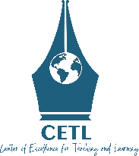  CETL the Brightest Mind Scholarship Program (CETL_BMS)  Donation Form/ Contributory Form | 

Donor’s/Contributor’s Information
NAME: | Occupation:
ADDRESS: | EMAIL:
CITY, STATE, ZIP: | PHONE:
WEBSITE: | Are you working at Green University of Bangladesh: Yes No

Donation Description
CHECK ONE: Direct Cash Transfer to Bank Mobile Payment Other…………………

Please write CETL_BMS in the reference while making payment through any of the above options
AMOUNT / DESCRIPTION: (Please mention monthly/Yearly or Quarterly payment mode depending on your preference) | DATE AND SIGNATURE:
NOTE:

Contact Information
Centre of Excellence for Teaching and Learning (CETL)  Green University of Bangladesh  220/D Rokeya Sharoni, Agargaon,  Dhaka, Bangladesh  http://cetl.green.edu.bd/ | CETL Scholarship Programs Coordination  Phone: (+88-02) 9014725, 8031031, 8060116  Cell: (+88) 01757074304, 01757074302,  Email: cetl@green.edu.bd

